NAME:…………………………………………………………… ADM NO…………………

DATE……………………..

PHYSICS FORM 3
MID OF TERM ONE 2022 EXAM
MAY 2022
TIME: 2 HOURS

INSTRUCTIONS TO CANDIDATES
- Write your name and admission number in the spaces provided above.
- This paper consists of TWO sections: A and B
- Answer All questions in section A and B in the space provided.
- Show all the steps in your calculations, giving your answers at each stage in the spaces below each question.
Take: Acceleration due to gravity g = 10m/s²
Density of water 1 g/cm³
Density of mercury 13.6 g/cm³

SECTION A (40MARKS)

- Figure 1 below shows a measuring cylinder containing some water. A student added 200 drops of water into the measuring cylinder. The Fig 2 shows the measuring cylinder after the addition of the drops

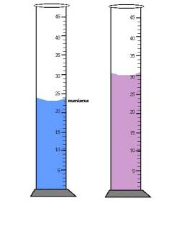
Fig 1 fig 2
a). State.
(i). The volume of the water added.
………………………………………………………………………………………………………………………………………………………………………………………… (2mks)

(ii). Average volume of one drop of water.
………………………………………………………………………………………………………………………………………………………………………………………………………………………………………………………………………………………………………………………
(2mks)
- State two ways of increasing the surface tension of a liquid (2 Marks)
………………………………………………………………………………………………………………………………………………………………………………………………………………………………………………………………………………………………………………………………………

- The figure below shows the transverse section of a water dam.

(a). Explain why engineers prefer this shape. (2 marks)
……………………………………………………………………………………………………………………………………………………………….,……………………………………………………………………………………………………………………………………………………………………

(b). Given that pressure at the deepest point is 400000N/m². Determine the depth of this point given that density of water is 1000kg/m³. (3mks)
…………………………………………………………………………………………………………………………………………………………………………………………………………………………………………………………………………………………………………………………………………………………………………………………………………………………………………………
4.a) Give a reason why the weight of a body on earth is greater than the weight of the same body on the moon. (2mks)
…………………………………………………………………………………………………………………………………………………………………………………………………………………………

b). An astronaut weighs 720N on the earth’s surface. On a certain planet he weighs 540N. Determine the gravitational acceleration on this planet. (Take g for earth = 10N/kg) (3mks)

………………………………………………………………………………………………………………………………………………………………………………………………………………………………………………………………………………………………………………………………………

5 a). State two properties of a good thermometric liquid (2 marks)
- ………………………………………………………………………………………………………………………………………………………………………………………………………

b) The figure below shows a clinical thermometer. State the purpose of the constriction. (1 mark)

…………………………………………………………………………………………………………………………………………………………………………………………………………
6. State Pascal’s principle of transmission of pressure in fluids. (1 mark)

……………………………………………………………………………………………………………………………………………………………………………………………………………………………………………………………………………………………………………………………………
7. 1600cm³ of fresh water of density 1 g/cm³ is mixed with 1400cm³ of sea water of density 1.25 g/cm³. Determine;
- The total mass of the mixture (2mks)
……………………………………………………………………………………………………………………………………………………………………………………………………………………………………………………………………………………………………………………………………………………………………………………….

- The density of the mixture (2 marks)
……………………………………………………………………………………………………………………………………………………………………………………………………………………………………………………………………………………………………………………………………….
8. Name two types of forces which can act between objects which are not in contact. (2 marks)
………………………………………………………………………………………………………………………………………………………………………………………………………………………………………………………………………………………………………………………………

9. State the kinetic theory of gases (1mark)
……………………………………………………………………………………………………………………………………………………………………………………………..

10. State one advantage of frictional force (1 mark)

……………………………………………………………………………………………………………………………………………………………………………………………..

11. A stop watch started 0.5s after the start button was pressed. The time recorded using the stop watch for a ball falling through a liquid was 2.53s. Determine the time of fall. (1mk)

12. State 2 properties of magnets.
……………………………………………………………………………………………………………………………………………………………………………………………………………………………………………………………………………………………………………………………………..

13. Explain why it is easier to loosen a nut using a spanner with a long handle than a spanner with a short handle. (2mks)
……………………………………………………………………………………………………………………………………………………………………………………………………………………………………………………………………………………………………………………….

14. State 2 ways in which the stability of a body can be increased. (2mks)
………………………………………………………………………………………………………………………………………………………………………………………………………………………………………………………………………………………………………………………………………

15. State one advantage and one disadvantage of using a convex mirror as driving mirror. (2mks)

……………………………………………………………………………………………………………………………………………………………………………………………………………………………………………………………………………………………………………………………………
16. A pipe of radius 6mm is connected to another pipe of radius 9mm . If water flows in the wider pipe at speed of 2m/s, what is the speed in the narrower pipe. (2mks)
……………………………………………………………………………………………………………………………………………………………………………………………………………………………………………………………………………………………………………………………………………………………………………………………………………………………………………………
17. A spring stretches by 10mm when supporting a load of 4N. Determine how much it would stretch when supporting a load of 12N. (3mks)
……………………………………………………………………………………………………………………………………………………………………………………………………………………………………………………………………………………………………………………………………………………………………………………………………………………………………………………………………………………………………………………

SECTION B 60 MARKS
- (a) What is anomalous expansion of water (1mk)
……………………………………………………………………………………………………………………………………………………………………………………………………………………………………………………………………………………………………………………

(b) Convert -123$°$ c to temperature to kelvin (2mks)
……………………………………………………………………………………………………………………………………………………………………………………………………………………………………………………………………………………………………………………………………………
(c) State the functions of the following features of a common thermometer
  - Bulb (1mk)
………………………………………………………………………………………………………………………………………………………………………………………………………………………………………………………………………………………………………………

  - Capillary bore (1mk)
…………………………………………………………………………………………………………………………………………………………………………………………………………………………………………………………………………………………………………………..
  - Glass stem (1mk)
…………………………………………………………………………………………………………………………………………………………………………………………………………………………
- (a) Differentiate between temperature and heat (2mks)
……………………………………………………………………………………………………………………………………………………………………………………………………………………………………………………………………………………………………………………………………………………………………………………………………………………

(b) Why are liquids poor conductors of heat than solids (1mk)
………………………………………………………………………………………………………………………………………………………………………………………………………………………………………………………………………………………………………………………………………
(c) Define convection (1mk)
………………………………………………………………………………………………………………………………………………………………………………………………………………………………………………………………………………………………………………………………………

(d) A lighted candle is placed inside a transparent box with two chimneys and a smoldering straw on one chimney as shown
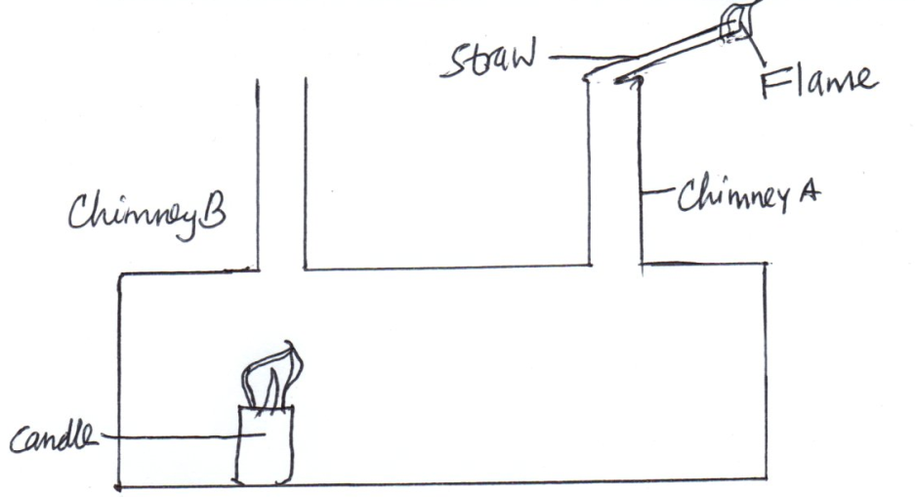
  - State and indicate what is observed in the box (1mk)
……………………………………………………………………………………………………………………………………………………………………………………………………………………………………………………………………………………………………………………

  - Explain your observation (2mks)
……………………………………………………………………………………………………………………………………………………………………………………………………………………………………………………………………………………………………………………………………………………………………………………………………………………………………………………
- (a) State two properties of a magnet (2mks)
………………………………………………………………………………………………………………………………………………………………………………………………………………………………………………………………………………………………………………………………………………
(b) State the basic law of magnetism (1mk)
………………………………………………………………………………………………………………………………………………………………………………………………………………………………………………………………………………………………………………………………………………
(c) Define magnetic field (1mk)

………………………………………………………………………………………………………………………………………………………………………………………………………………………………………………………………………………………………………………………………………………

(d) Draw the resultant, magnetic field pattern between two south poles below (2mks)

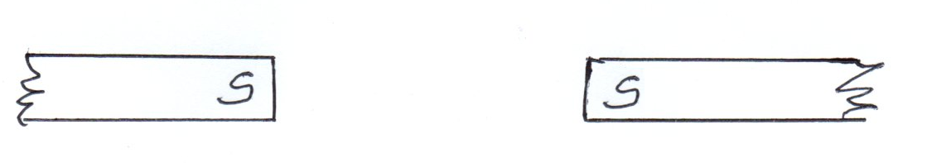

(e) The following diagram represent one method of making a magnet
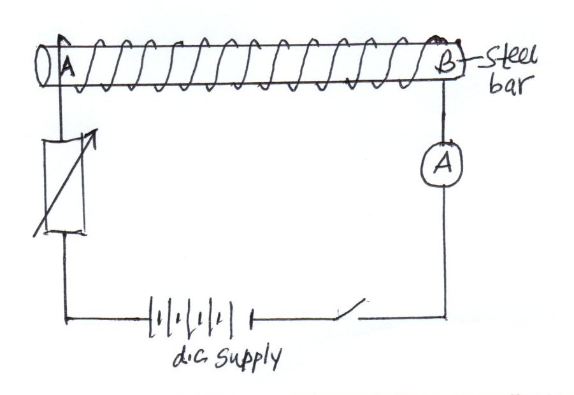
  - State the rule used to determine the poles of the attained magnet after the steel is magnetized.(1mk)
………………………………………………………………………………………………………………………………………………………………………………………………………………………………………………………………………………………………………………

  - Use the rule to determine the polarity of A and B. (1mk)
……………………………………………………………………………………………………………………………………………………………………………………………………………………………………………………………………………………………………………

- (a)
The following diagram shows a current flowing in a straight conductor as shown. Draw the magnetic field pattern showing its direction (2mks)
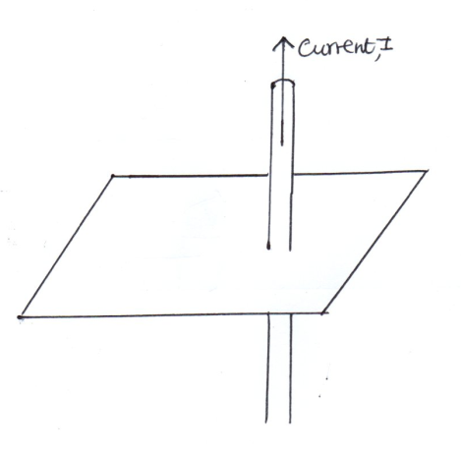
(b) (i) State one factor on which the magnetic strength of an electromagnet depends on showing how each factor relates to strength. (1mk)
………………………………………………………………………………………………………………………………………………………………………
(ii) How does the factor you have stated above in b (i) affect the magnetic strength of an electromagnet (1mk)
………………………………………………………………………………………………………………………………………………………………………………………………………………………………………………………………………………………………………………………………………………
(c) A straight current carrying conductor is placed between two poles of bar magnets as shown below.
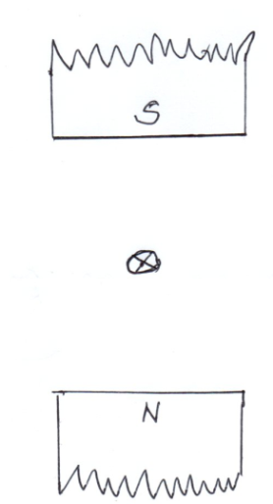
- Draw the resultant field lines after interaction of the magnetic fields of the poles and those of the conductor. (2mks)

- Indicate the direction of the force acting on the conductor (1mk)

- (a) Define the following terms:
  - Transverse waves (1mk)
………………………………………………………………………………………………………………………………………………………………………………………………………………………………………………………………………………………………………………

  - Longitudinal waves (1mk)
…………………………………………………………………………………………………………………………………………………………………………………………………………

(b) A water wave travels 12m in 4s. If the frequency of the waves is 2Hz, calculate
- The speed of the wave (2mks)

- The wavelength of the wave (3mks)

- (a)
The prongs of a tuning fork are made to vibrate by striking them against a hard surface and vibrate
  - Draw the waves produced (2mks)
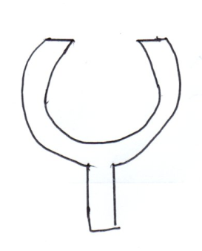
  - Name the type of wave drawn (1mk)
………………………………………………………………………………………………………………………………………………………………………

(b) State two factors which affect velocity of sound in air (2mks)
…………………………………………………………………………………………………………………………………………………………………………………………………………
(c) Two boys stood 200m from a wall. One banged two pieces of wood together while the second one started a stop watch and stopped it when he heard the echo. If the time shown on the stop watch was 1.2 seconds. Calculate the speed of sound in air. (3mks)

- (a)
A form 2 student used a vernier calipers to measure the diameter of a ball bearing. Determine the reading shown (2mks)
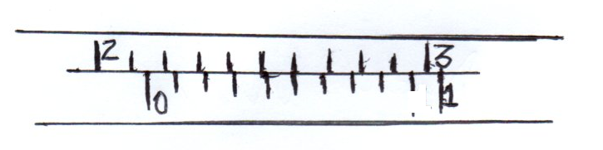

(b) An oil drop of diameter 0.5 mm spreads on the surface of water to form an oil patch of diameter 0.2m. Estimate the thickness of the oil patch.(3mks)

- (a) Define the following terms as applied in curved mirrors
  - The pole (1mk)
……………………………………………………………………………………………………………………………………………………………………………………………………………………………………………………………………………………………………………………
  - Center of curvature (1mk)
……………………………………………………………………………………………………………………………………………………………………………………………………………………………………………………………………………………………………………………

(b) An object pin of height 2cm is placed 4cm in front of a concave mirror of focal length 3cm. construct a ray diagram by scale drawing to find the position of the image (3mks)

From your diagram, determine
  - The image distance (1mk)

…………………………………………………………………………………………………………….
  - Magnification of the image (2mks)
……………………………………………………………………………………………………………………………………………………………………………………….

- (a) State the principle of moments (1mk)

…………………………………………………………………………………………………………………………………………………………………………………………………………………………

(b) A uniform wooden bar, 100cm long balances at 70 cm mark when a mass of m kg is attached at 100cm mark as shown below.
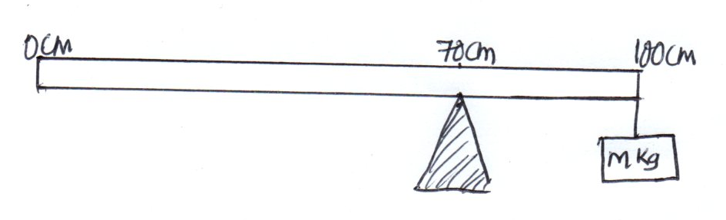
If the mass of the wooden bar is 200 g, find the mass, m which balances the wooden bar (g = 10N/kg) (3mks)

